ASEN 5090-001 Homework #05

Submitted By

Charles Goble

Aerospace Engineering Sciences Department

University of Colorado at Boulder

Submitted: October 17, 2016

**Table of Contents**

Executive Summary 03

Objective 04

Method and Procedure 05

Results/Discussion 06

Conclusions and Recommendations 14

References 15

**Executive Summary**

This document outlines the problem solving process and results for the set homework assignment. The document is broken down into several sections. The first section is the objective section. One objective has been identified. Following the objective section is the methods and procedures. The work completed is straightforward however, the author was not able to complete the assignment. The results section follows the method/procedure section. The results obtained are consistent with the expected results, but incomplete. The analysis and discussion section describes in detail how each of the results are obtained. Following the analysis and discussion section is the conclusion and recommendation section. This section is short, again, this assignment is straightforward and does not necessarily require a large report to show results. The final sections are the references and the appendix. All computer code has been submitted to the reader and is not in an appendix section.

**Objective**

The objective of this document is to fully demonstrate adequate understanding of the covered course material as well as present solutions to assigned problem using proper engineering problem solving processes. Specifically, the main learning outcome of this homework assignment is to gain a thorough understanding of concepts of GPS satellite orbit, ephemeris and broadcast data.

**Methods and Procedures**

The methodology and procedures followed are straight forward and concise. All procedures used to solve the problem are from either course notes or the course textbook. The most direct approach was used to solve all of the problems. All computations, excluding problem 5, used MATLAB as the programming language.

**Results/Discussion**

The following are the solutions obtained for the assigned problems. Each solution will be presented and follow on discus will be below the solution when required.

Problem 1:

Table 1: Orbit Plane of PRN from Yuma File

|  |  |  |
| --- | --- | --- |
| PRN | RAAN Degrees | Orbit Plane |
| 1 | 8.4618 | D |
| 2 | 5.7117 | D |
| 3 | 68.1432 | E |
| 5 | 67.3740 | E |
| 6 | 7.7998 | D |
| 7 | 189.4398 | A |
| 8 | 307.6252 | C |
| 9 | 127.6211 | F |
| 10 | 67.9193 | E |
| 11 | 346.3913 | D |
| 12 | 251.2248 | B |
| 13 | 134.6391 | F |
| 14 | 132.4738 | F |
| 15 | 124.4467 | F |
| 16 | 252.3016 | B |
| 17 | 310.7283 | C |
| 18 | 66.0242 | E |
| 19 | 313.5059 | C |
| 20 | 63.0665 | B |
| 21 | 6.35073 | D |
| 22 | 66.0476 | E |
| 23 | 127.8600 | F |
| 24 | 186.6235 | A |
| 25 | 248.2322 | B |
| 26 | 247.6034 | B |
| 27 | 307.8310 | C |
| 28 | 252.5780 | B |
| 29 | 311.2924 | C |
| 30 | 191.8766 | A |
| 31 | 190.0048 | A |
| 32 | 127.7335 | F |

Problem 1 was solved by loading the gps Yuma file into MATLAB, from there the longitude of the ascending node was determined for each PRN in the Yuma file. Using the epoch of the Yuma file, the Greenwich Mean Sidereal Hour Angle was calculated. Finally, Using the longitude of the ascending node and the Greenwich Mean Sidereal Hour Angle, RAAN was calculated.

Problem 2:

Boulder, CO

Geodetic Latitude: 40 degrees

Geodetic Longitude: 105 degrees

Altitude 1631 meters

Table 2: ECEF Frame Position of Boulder, CO

|  |  |  |  |  |  |
| --- | --- | --- | --- | --- | --- |
| Position of Boulder, CO in ECEF Frame | | | | | |
| X position | -1.2666E6 m | Y position | -4.7272E6 m | Z position | 4.0790E6 m |

Problem 2 used the following equations to transform geodetic latitude, longitude and altitude to the ECEF frame position vector.



In the above set of equations, λ is the latitude, is the geodetic longitude and h is the altitude. The parameters R, C, *f*, and e are the wgs84 ellipsoid parameters.

Problem 3

Observer position: 

Table 3: Visible Satellites from Boulder, CO

|  |  |  |  |
| --- | --- | --- | --- |
| PRN | Azimuth [deg] | Elevation [deg] | Range [m] |
| 2 | 136.5598 | 85.1450 | 2.0337E07 |
| 4 | 193.5717 | 52.0431 | 2.1166E07 |
| 5 | 297.6605 | 59.3375 | 2.0779E07 |
| 6 | 127.6586 | 41.3411 | 2.1912E07 |
| 7 | 80.0337 | 25.4639 | 2.3463E07 |
| 9 | 44.7091 | 17.1058 | 2.3979E07 |
| 13 | 203.5449 | 32.6161 | 2.2612E07 |
| 15 | 220.3057 | 4.4863 | 2.5141E07 |
| 19 | 173.3221 | 6.2577 | 2.5360E07 |
| 20 | 272.3507 | 8.9151 | 2.4757E07 |
| 29 | 309.7061 | 25.9670 | 2.3161E07 |
| 30 | 111.5575 | 23.8217 | 2.3399E07 |

Problem 3 used the following equations to transform the ECEF frame position vector of an observer and the ECEF frame position vector of a satellite to find the azimuth, elevation and range relative to the two bodies.



Problem 4:

This problem was solved using the functions written to solve the previous problems.

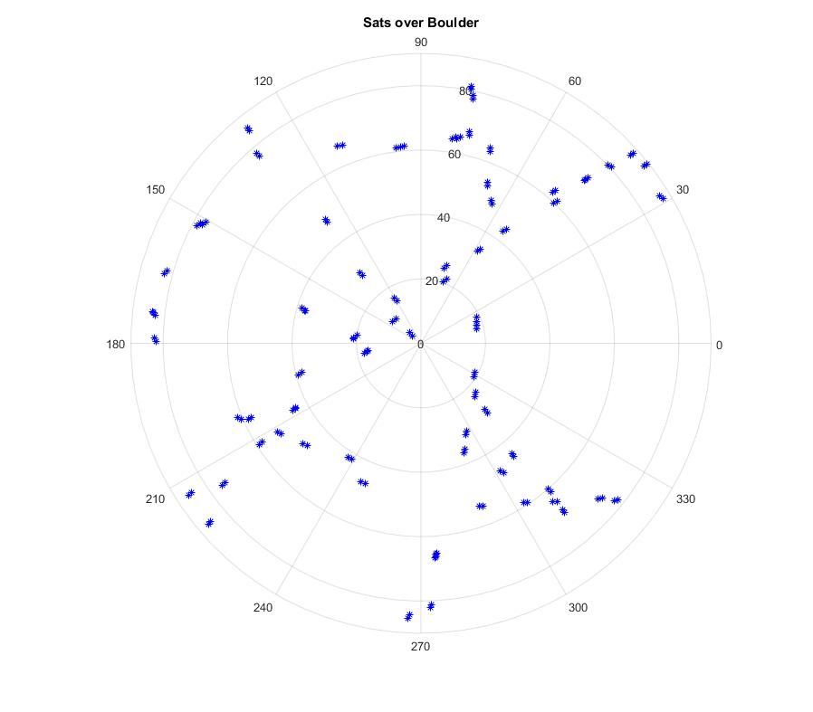  
Figure 1: Visible Satellites over Boulder, CO

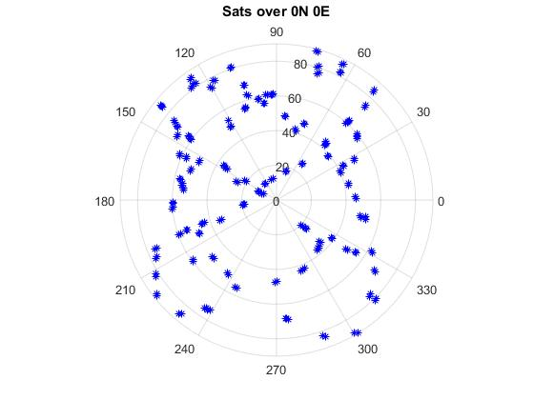  
Figure 2: Visible Satellites over 0N, 0E

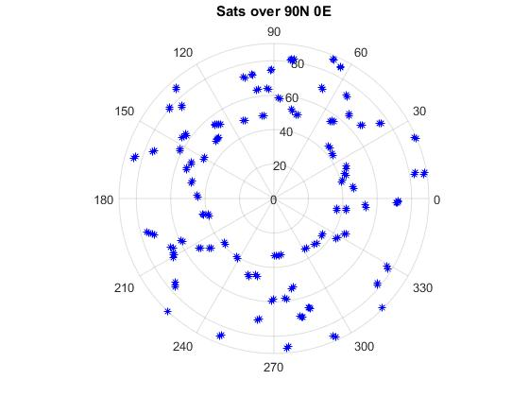  
Figure 3: Visible Satellites over 90N, 0E

Figures one through three do not show the full propagation of the satellite motion over the intended time interval. The figures do show the position at each update period found in the broadcast transmission. Even though the plots do not show fully propagated motion noticeable visibility trends are apparent. Figure 1 shows the coverage over Boulder, CO. There is a noticeable hole from ± 30◦ azimuth angle and from the horizon to + 70◦ elevation angle. Figure two does not show a noticeable hole in satellite coverage. This is to be expected. The observation location is at the center of the map where visibility is at its maximum. Finally, in figure three there is a noticeable hole at high elevation angles. This is to be expected. The observation location for figure three is the north pole, at such a high latitude the GPS satellites will not be visible high on the horizon because of the inclination of the GPS satellite orbits.

Problem 5:

G:\School\Fall 2016\ASEN 5090\Homework\HW 05\REPORT\problem 5.tif

Problem 6:

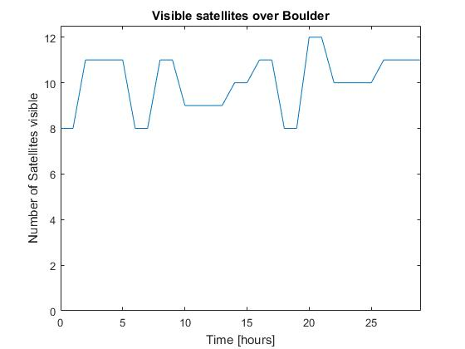  
Figure 4: Visible Satellite over Boulder, CO

Problem six was solved in a similar manner to problem 4. The exact same procedure was used; the only change was to the elevation mask. The elevation mask was raised to 10 degrees.

Problem 7:

Table 4: Range0 and Range1 of PRN 02

|  |  |
| --- | --- |
| PRN 02 | |
| Range0 [m] | Range1 [m] |
| X = 3.08235E6 | X = 3.08235E6 |
| Y = 16.0761E6 | Y = 16.0761E6 |
| Z = 12.0678E6 | Z = 12.0678E6 |

Table 5: Residual in Range0 and Range1

|  |
| --- |
| Difference in Range0 and Range1 [m] |
| ∆X = 1.8626E-9 |
| ∆Y = 7.4505E-9 |
| ∆Z = 1.8626E-9 |

The algorithm used to determine the solution to problem 7 is the same algorithm outlined at the end of the homework problem set.

1. Compute the GPS satellite position ECEF at Tr based on the broadcast ephemeris
   1. This was done using the ECI2ECEF function written for previous problems
2. Use an *a priori* value for the receiver coordinates (RX) to find the geometric range.
3. Compute the time of transmission
4. Compute the satellite position at T_transmission in ECEF frame based on the broadcast ephemeris
5. Rotate the satellite to ECEF at time of receiving
6. Compute a new geometric range using this position for radius of GPS
7. Repeat steps 2-6 until convergence.

**Conclusions and Recommendations**

Concluding, this homework set has been unsuccessful and has failed to meet the objective of the assignment. Overall, the assignment was challenging, it allowed the author to think critically about the real GPS orbits and how the ephemeris data assists with position determination. The author did a poor job with time management and failed to complete the assignment.

References

1. Misra, Pratap, and Per Enge. *Global Positioning System: Signals, Measurements, and Performance*. Lincoln, MA: Ganga-Jamuna, 2011. Print.